**Physical Development**

* Gross Motor movements during moving time.
* PE sessions: Throwing and catching, active athletics.
* Funky Finger activities: weaving, threading, joining, slotting shapes together, drawing and colouring pictures linked to ‘bees trees and seed’.

- Using tools and equipment like staplers

Sellotape, masking tape, hole punchers and

scissors with increasing accuracy.

**Personal, Social and Emotional Development**

- Seasons

- Life stages - plants, animals, humans.

- Life Stages: Human life stage - who will I be?

**Communication, Language**

**and Literacy**

* Asking questions to find out more
* Connect one idea to another using connectives
* Describing events

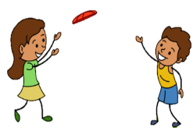

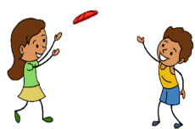



**Maths**

* Teen numbers
* More and less
* Ordering objects
* Adding
* Subtraction



**Literacy**

- Phonics: Learning single letter sounds and set 2 sounds. Blending sounds to read words and writing simple words and sentences

-Texts: Jack and the beanstalk. Three billy goats gruff

- Reading; learning new vocabulary for poetry

- Writing: Form lower case letters, write sentences, labelling, rehearsing simple story sentences

**Parent Overview - YR Hedgehogs**

**Summer 1– 2022**

**Bees, Trees and Seeds**



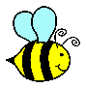

**Key Texts** 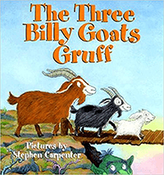

Jack and the beanstalk

The billy goats gruff

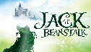

[This Photo](https://awesomelyluvvie.com/2017/04/jack-colonialist-beanstalk.html) by Unknown Author is licensed under [CC BY-NC-ND](https://creativecommons.org/licenses/by-nc-nd/3.0/)

**Understanding the World**

- describe the environment – look at maps and where we live

-identify similarities and differences for Bourton and London

- Observe seasonal changes

**Area Enhancements**

Garden centre

Fruit and vegetable stall

Garden party

**Expressive Arts and Design**

- Learn where food comes from – fruit and vegetables

- Cutting food

- Singing

- Acting out Jack and the beanstalk

**RE**

Key Question: Is Shabbat important to Jewish children

