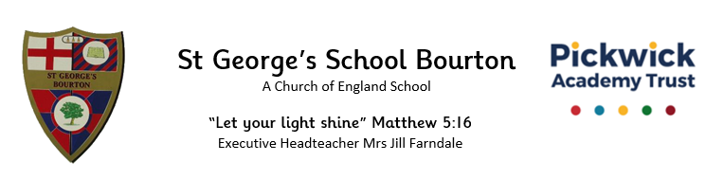

Friday 12th September 2025

Dear Badgers,

It was fantastic to welcome all the Badgers’ children back to school last week and to see some of you at our Meet the Teacher session on Tuesday. This letter is just to let you know our routines and what to expect in Badgers’ class.

**Staffing**

Miss Moores teaches all day on Mondays and Tuesdays, and Wednesday mornings. Mrs Welshman teaches Badgers all day on Thursday and Fridays. On Wednesday afternoons Mrs Milsom will be teaching Badgers as PPA cover. Ms Gregory and Miss Travers will also be supporting Badgers’ children with their learning every day. We are very lucky that Prime Sports will be teaching Badgers on Thursday for PE and Chance to Shine cricket will be leading a session on Fridays.

**The school day**

A copy of our timetable can be found as part of the Meet the Teacher slides on Badgers’ class page on the school website. Our PE days are currently Thursday and Friday. We do both outside and indoor PE so the children will need trainers for outside as part of their kit. As the weather gets colder, plain, dark jogging bottoms and dark, plain jumpers or the school PE hoodie will be required too. Please ensure everything is clearly named.

**What pupils need**

We try to keep what the children bring into school to a minimum; we have very little space in the cloakroom. We kindly ask that children only bring in the following items:

-Water bottle (essential, named)

-Lunchbox (if not having hot lunches, named)

-Snack – fresh fruit and/or vegetables only please. Please ensure it can be identified by placing it in a named tub or bag because the children put these in a box until playtime.

-Reading book and reading record – ideally kept in a separate wallet or bookbag in case of drink spillages.

-Coat with a hood (essential) – we like to ensure the children have some fresh air, even if it is drizzly, so please ensure your child brings a suitable coat every day.

All other equipment, including pens and pencils, are provided so please do not bring these into school. We have also reminded the children that they should not bring any toys, games or other belongings to school.

**Forest School**

Unlike last year, each of the classes will be having 1 forest school session every 4 weeks. Badgers first forest school session for this year will be Friday 3rd October. The children will need to wear warm clothing and bring a waterproof coat, waterproof trousers (if preferred) and a pair of welly boots. They are very likely to get muddy so please ensure all clothing is not their best. Please can all clothing (forest school and school uniform) and footwear be clearly named.

**Homework**

Reading remains crucial at Key stage 2 and we recommend your child reads at least 4 times a week at home to an adult and records this in their reading record. It is also hugely beneficial for children to hear books being read to them, often at a slightly higher level than they can read themselves. We know they enjoy our class reader each day in school.

Children also need to continue to learn their times tables. The national expectation is by the end of Year 4, all children know all multiplication facts up to 12x12 with quick recall. We highly recommend pupils use TTRockstars to help develop fluency with their recall of multiplication facts. As we work through these in class, will be setting challenges for the children to complete on TTRockstars at home and in school. We use it regularly at school, but it would be beneficial if they do 5 minutes 3-4 times a week at home too. In June, Year 4s will take part in a National Multiplication Tables Check (MTP) and we want to ensure they are as prepared as they can be.

We generally do not set other homework, although we may have an occasional research project based on the enquiry. If this happens, we will let you know via email. However, children are welcome to conduct their own research at home on any of our enquires and bring it in to share with us all.

**Enquiries**

Each half term we will be working towards answering an enquiry question starting with ‘What is sound?’ this half term. The children will be scientists and engineers as they work towards their final challenge. A copy of our first enquiry map of the year has been sent out but can also be found on our class page on the school website.

Throughout the year if you have any questions or concerns, please do not hesitate to speak to us at drop off/ pick up time or to email the office.

Kind regards,

Miss Moores and Mrs Welshman